**Lab4 readme**

Chenran Gong

**1. HelloWorld**

In my zip that handed in, the helloworld project is named as “ODE_Test4”

Deployment of the HelloWorld process:

After input the url (<http://localhost:8080/ode/services/listServices>) in browser, it looks below:

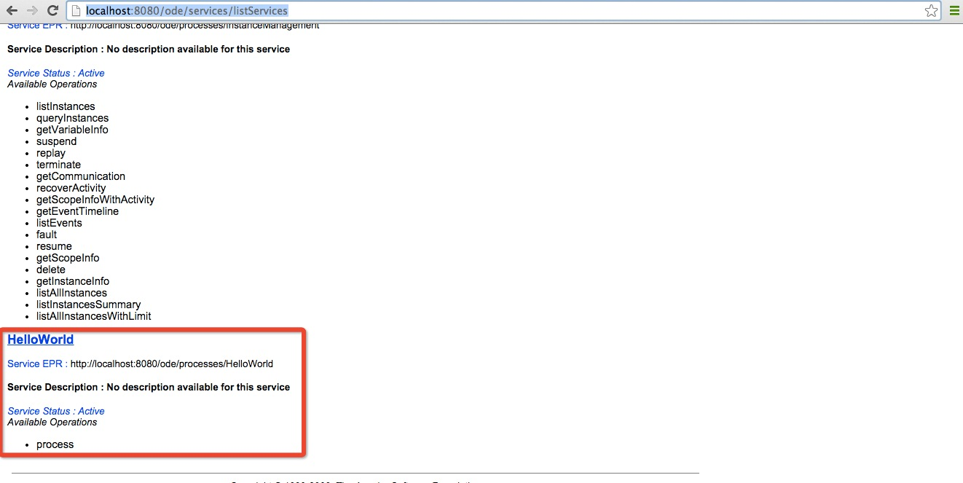

And the console shows correctly:

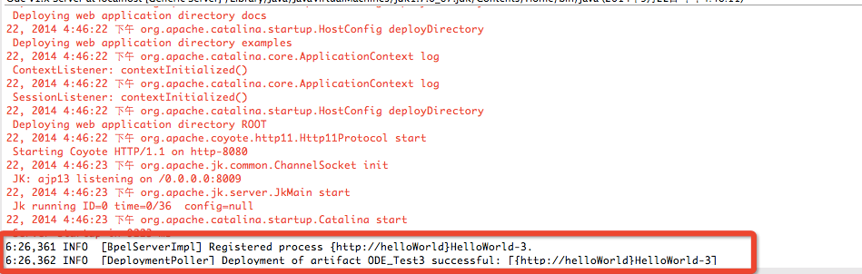

After starting Test with the web service explorer, it runs properly and the output result is exactly same with the input.

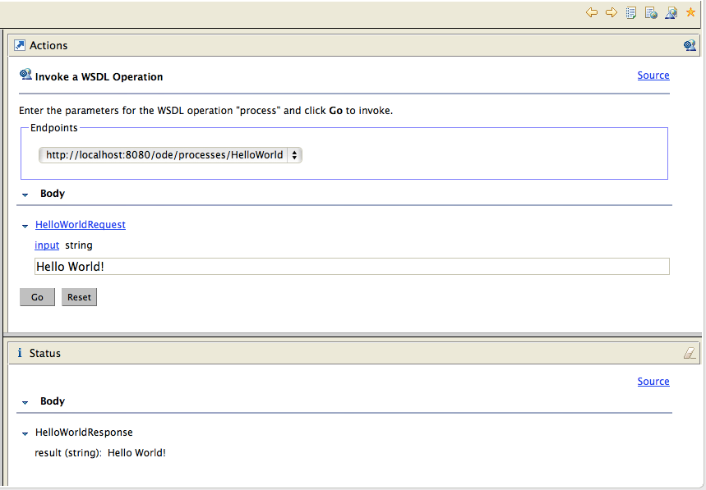

Moreover, my HelloWorldArtifacts.wsdl shows as below:

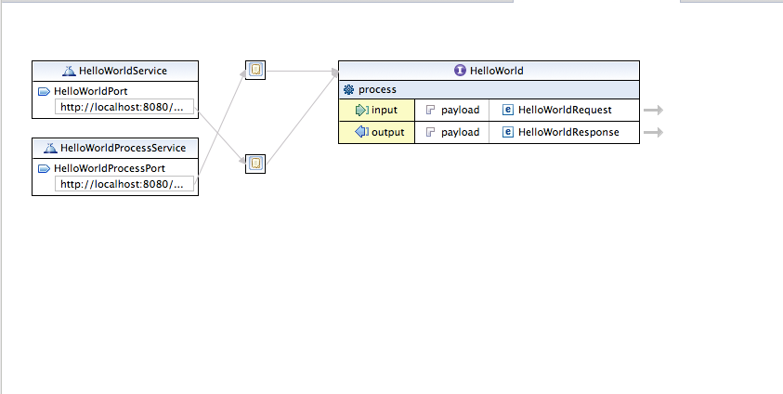

Maybe because of the BPEL plugin-in in eclipse Mac version, the HelloWorldService is automatically generated. If I delete it or modify it , it cannot run properly and cannot have any result.

So I can only add one more service and port below. And I set all the properties by myself and everything goes well.

That’s the reason why my WSDL file have two services and bindings.

**2. TravelAgency lab**

In the lab, I implemented a BPEL process about travel agency.

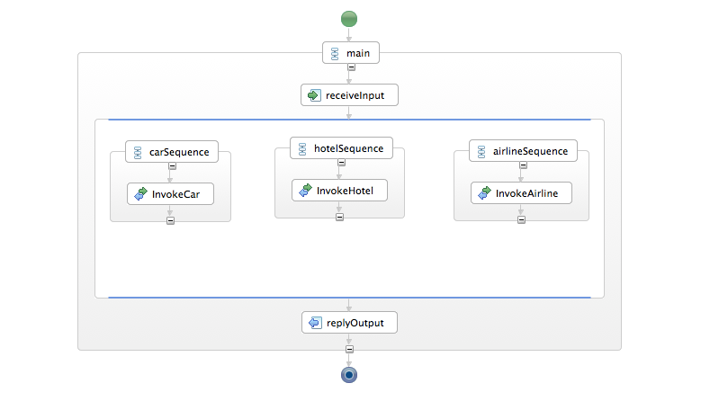

The project includes three WSDL file that I found from websites.

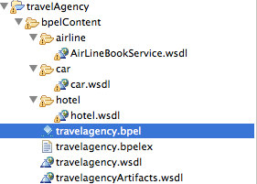

The travelagency.bpel file import these three WSDL file and invoke the WebService.

First, the travelagency.bpel file receives input information, and then can invoke Car service, flight service and hotel service. At last, the result of the three services will be in replyOutput.